**Evidence for Project Unit**

Rachael Ellen E20

**P. 1 Github Contributors page**

Castle Finder GitHub Repo. Contributions were made on Develop branch as work is still in progress and not ready to commit to master branch. Showing commits below.

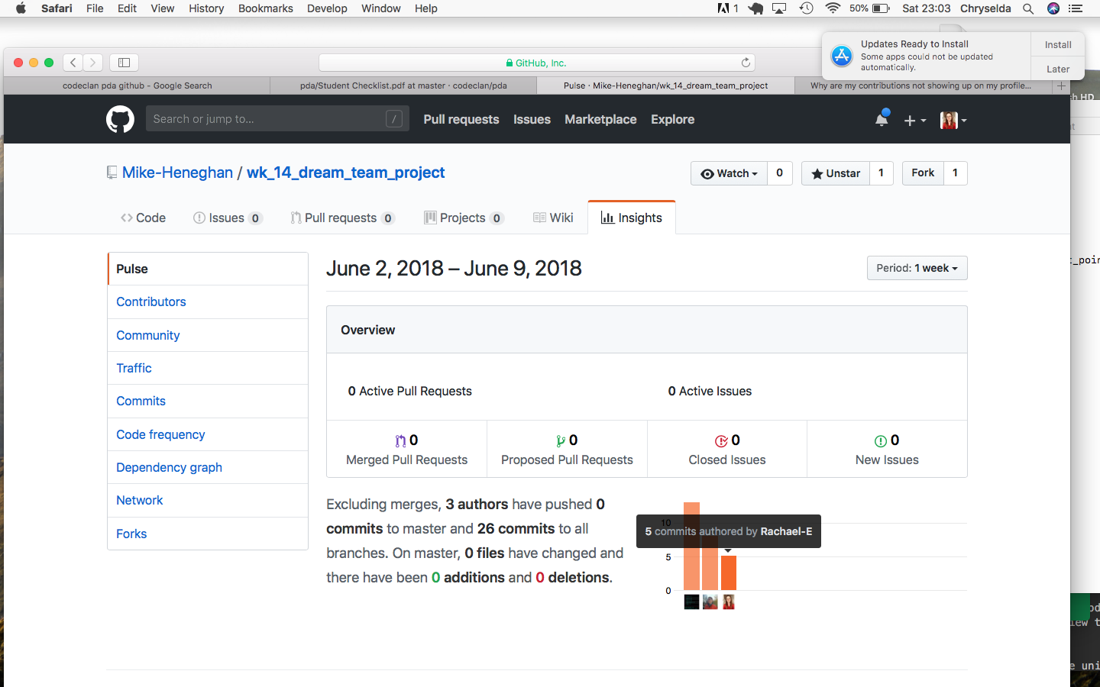

**P. 2 Project Brief**

Project brief for Group Project (Castle Finder)

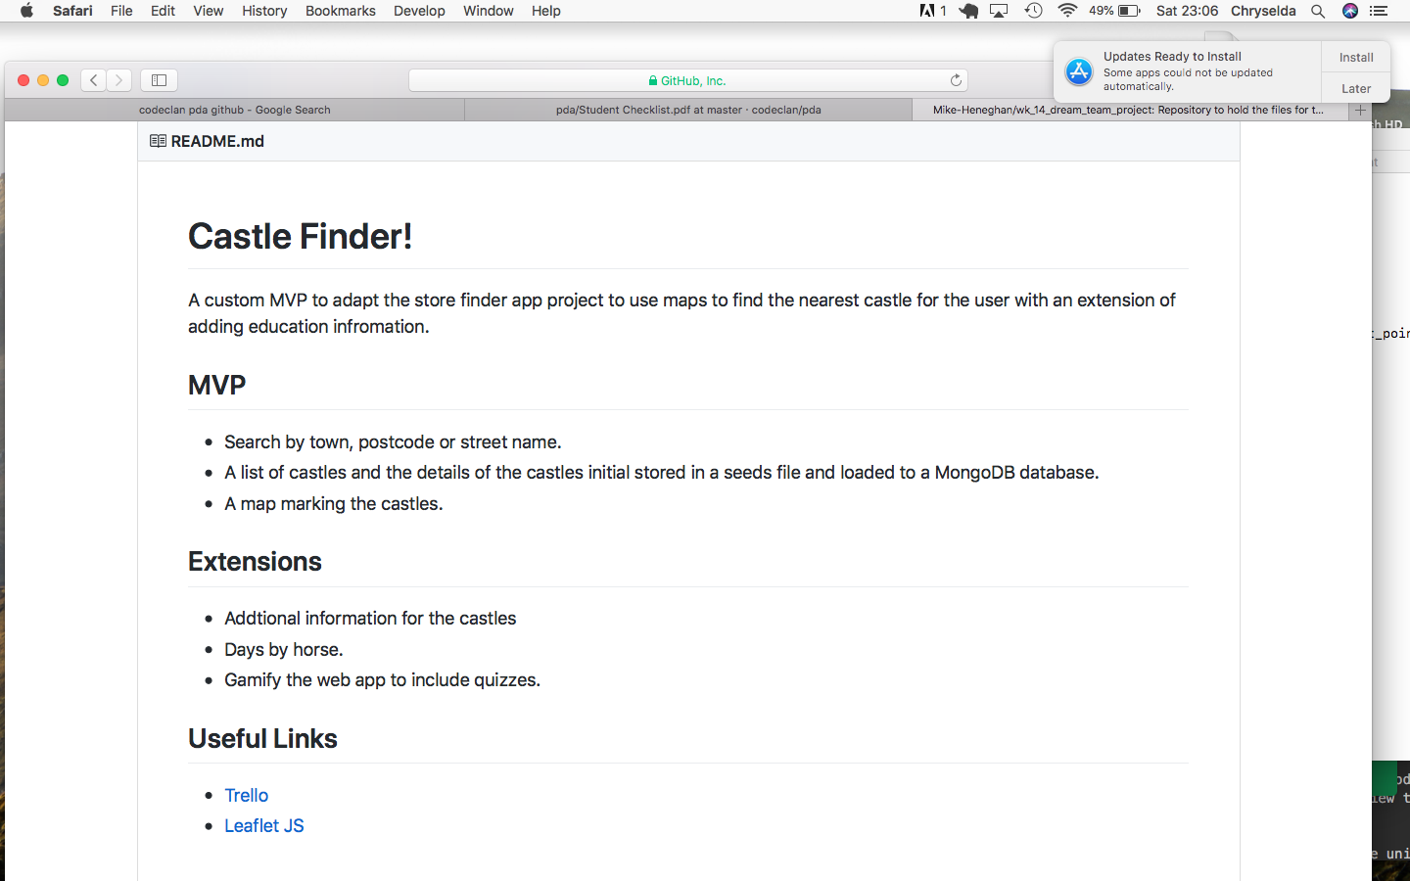

**P. 3 Use of Trello**

Planning on Trello for Group Project (Castle Finder)

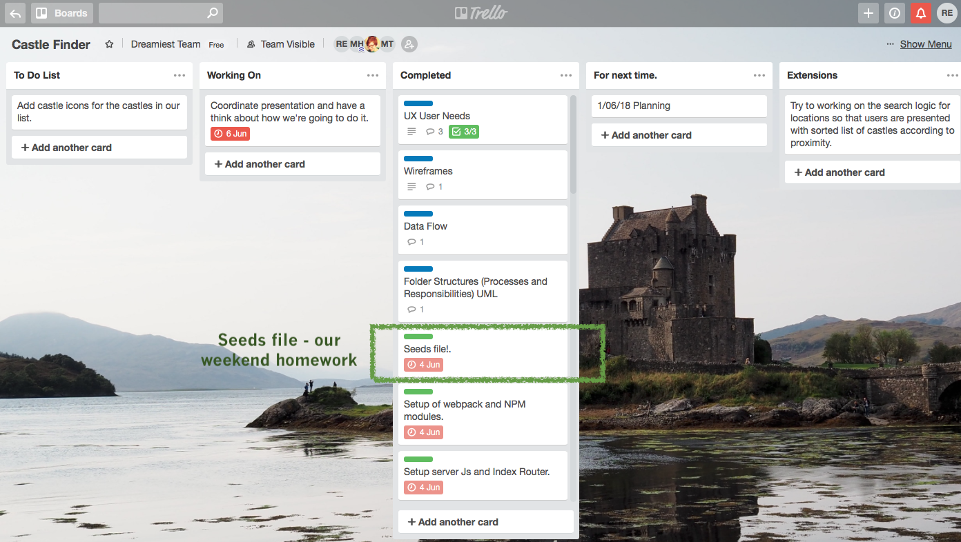

**P. 4 Acceptance Criteria**

Acceptance criteria for Castle Finder web application built in JavaScript.

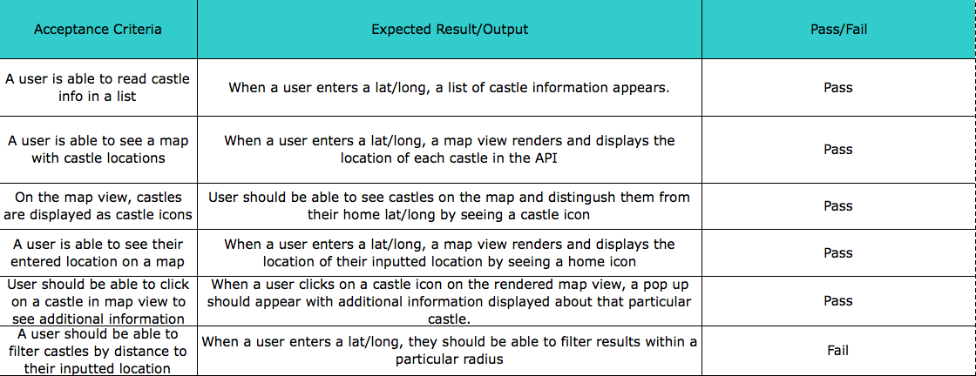

**P. 5 User sitemap**

User sitemap for Ruby Individual Project (Pet shop)

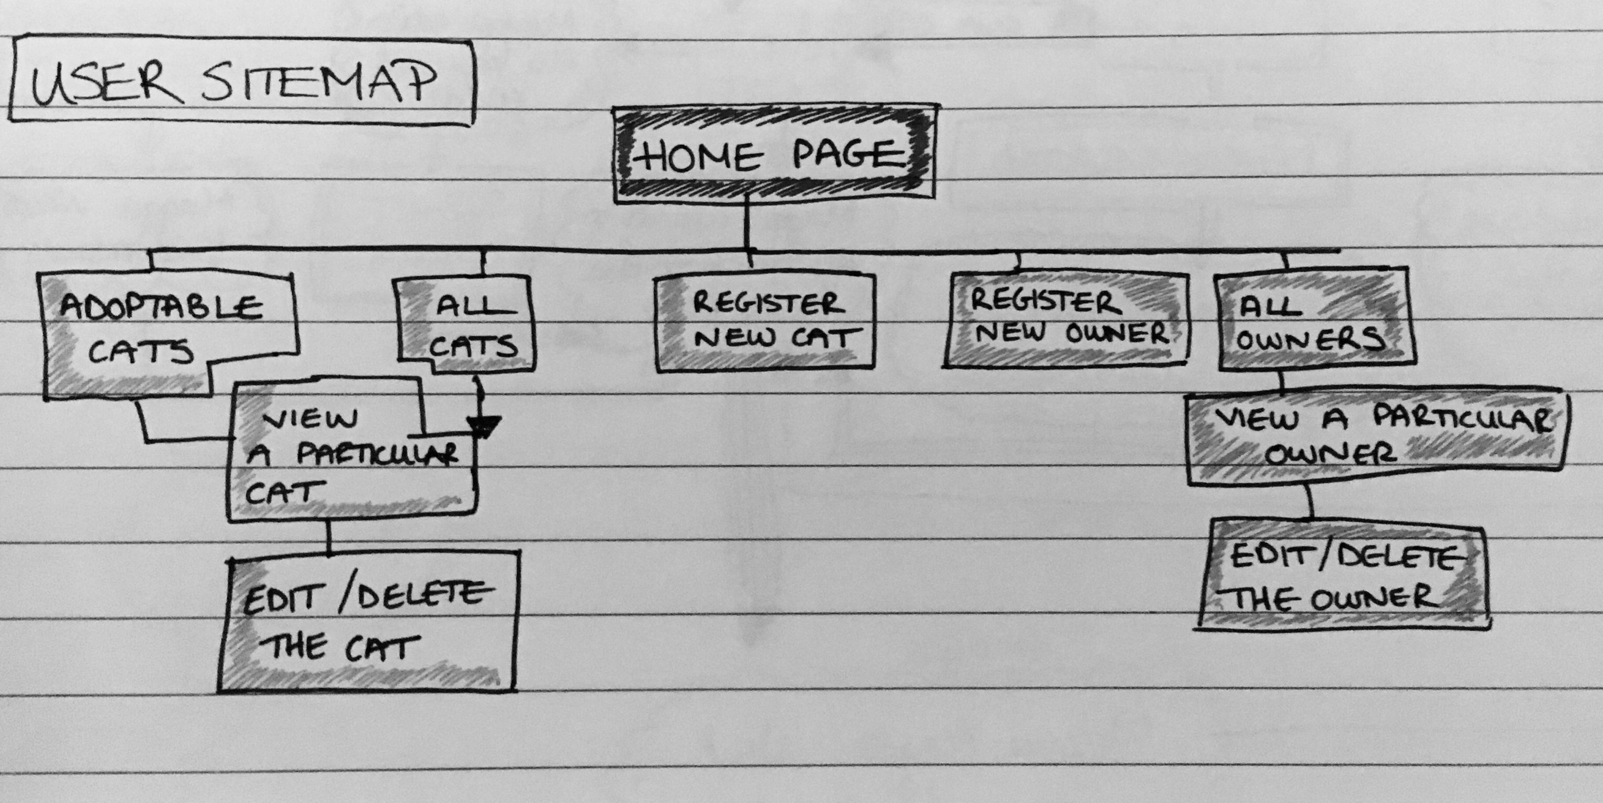

**P. 6 Wireframes designs**

Wireframe for Ruby Individual Project (pet shop)

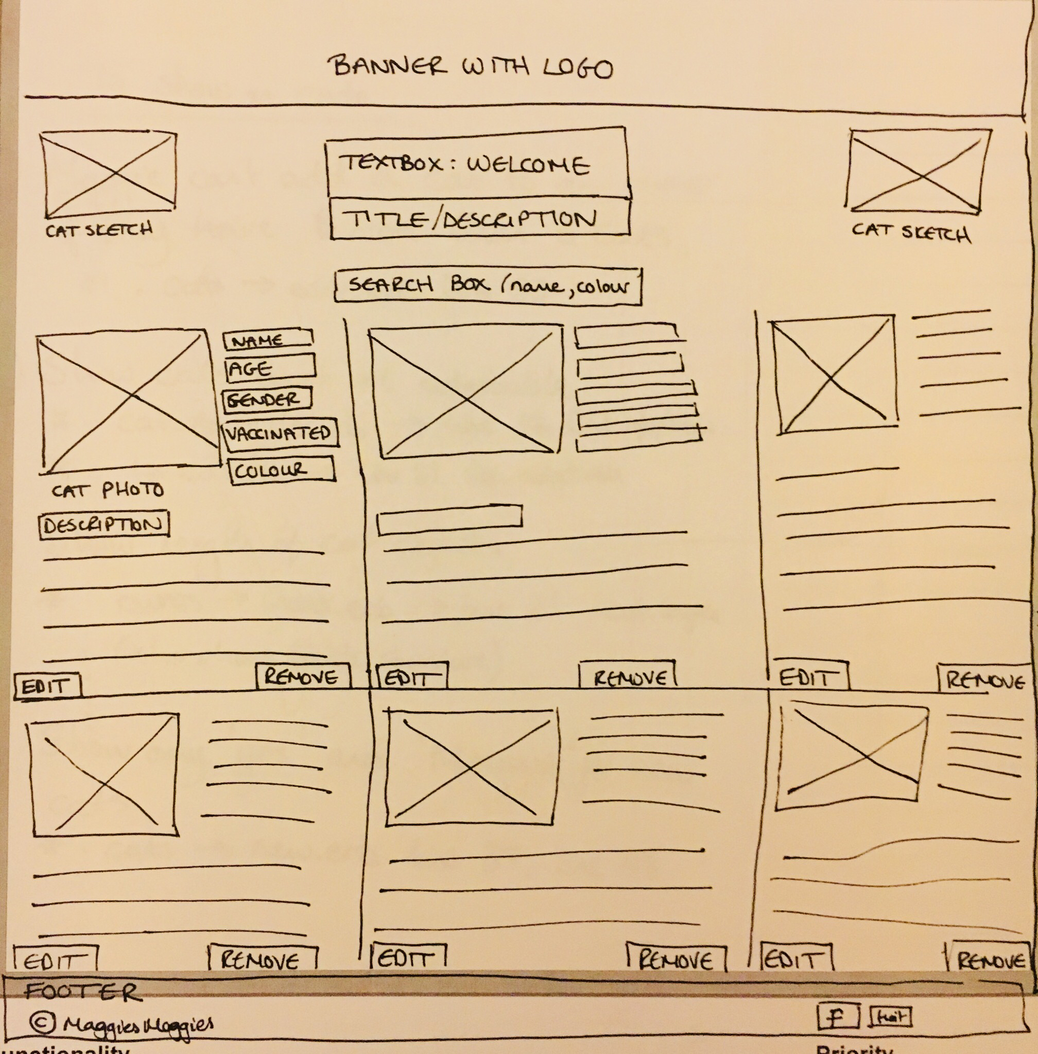

Wireframe for Android/Java Individual Project (GeoTracker)

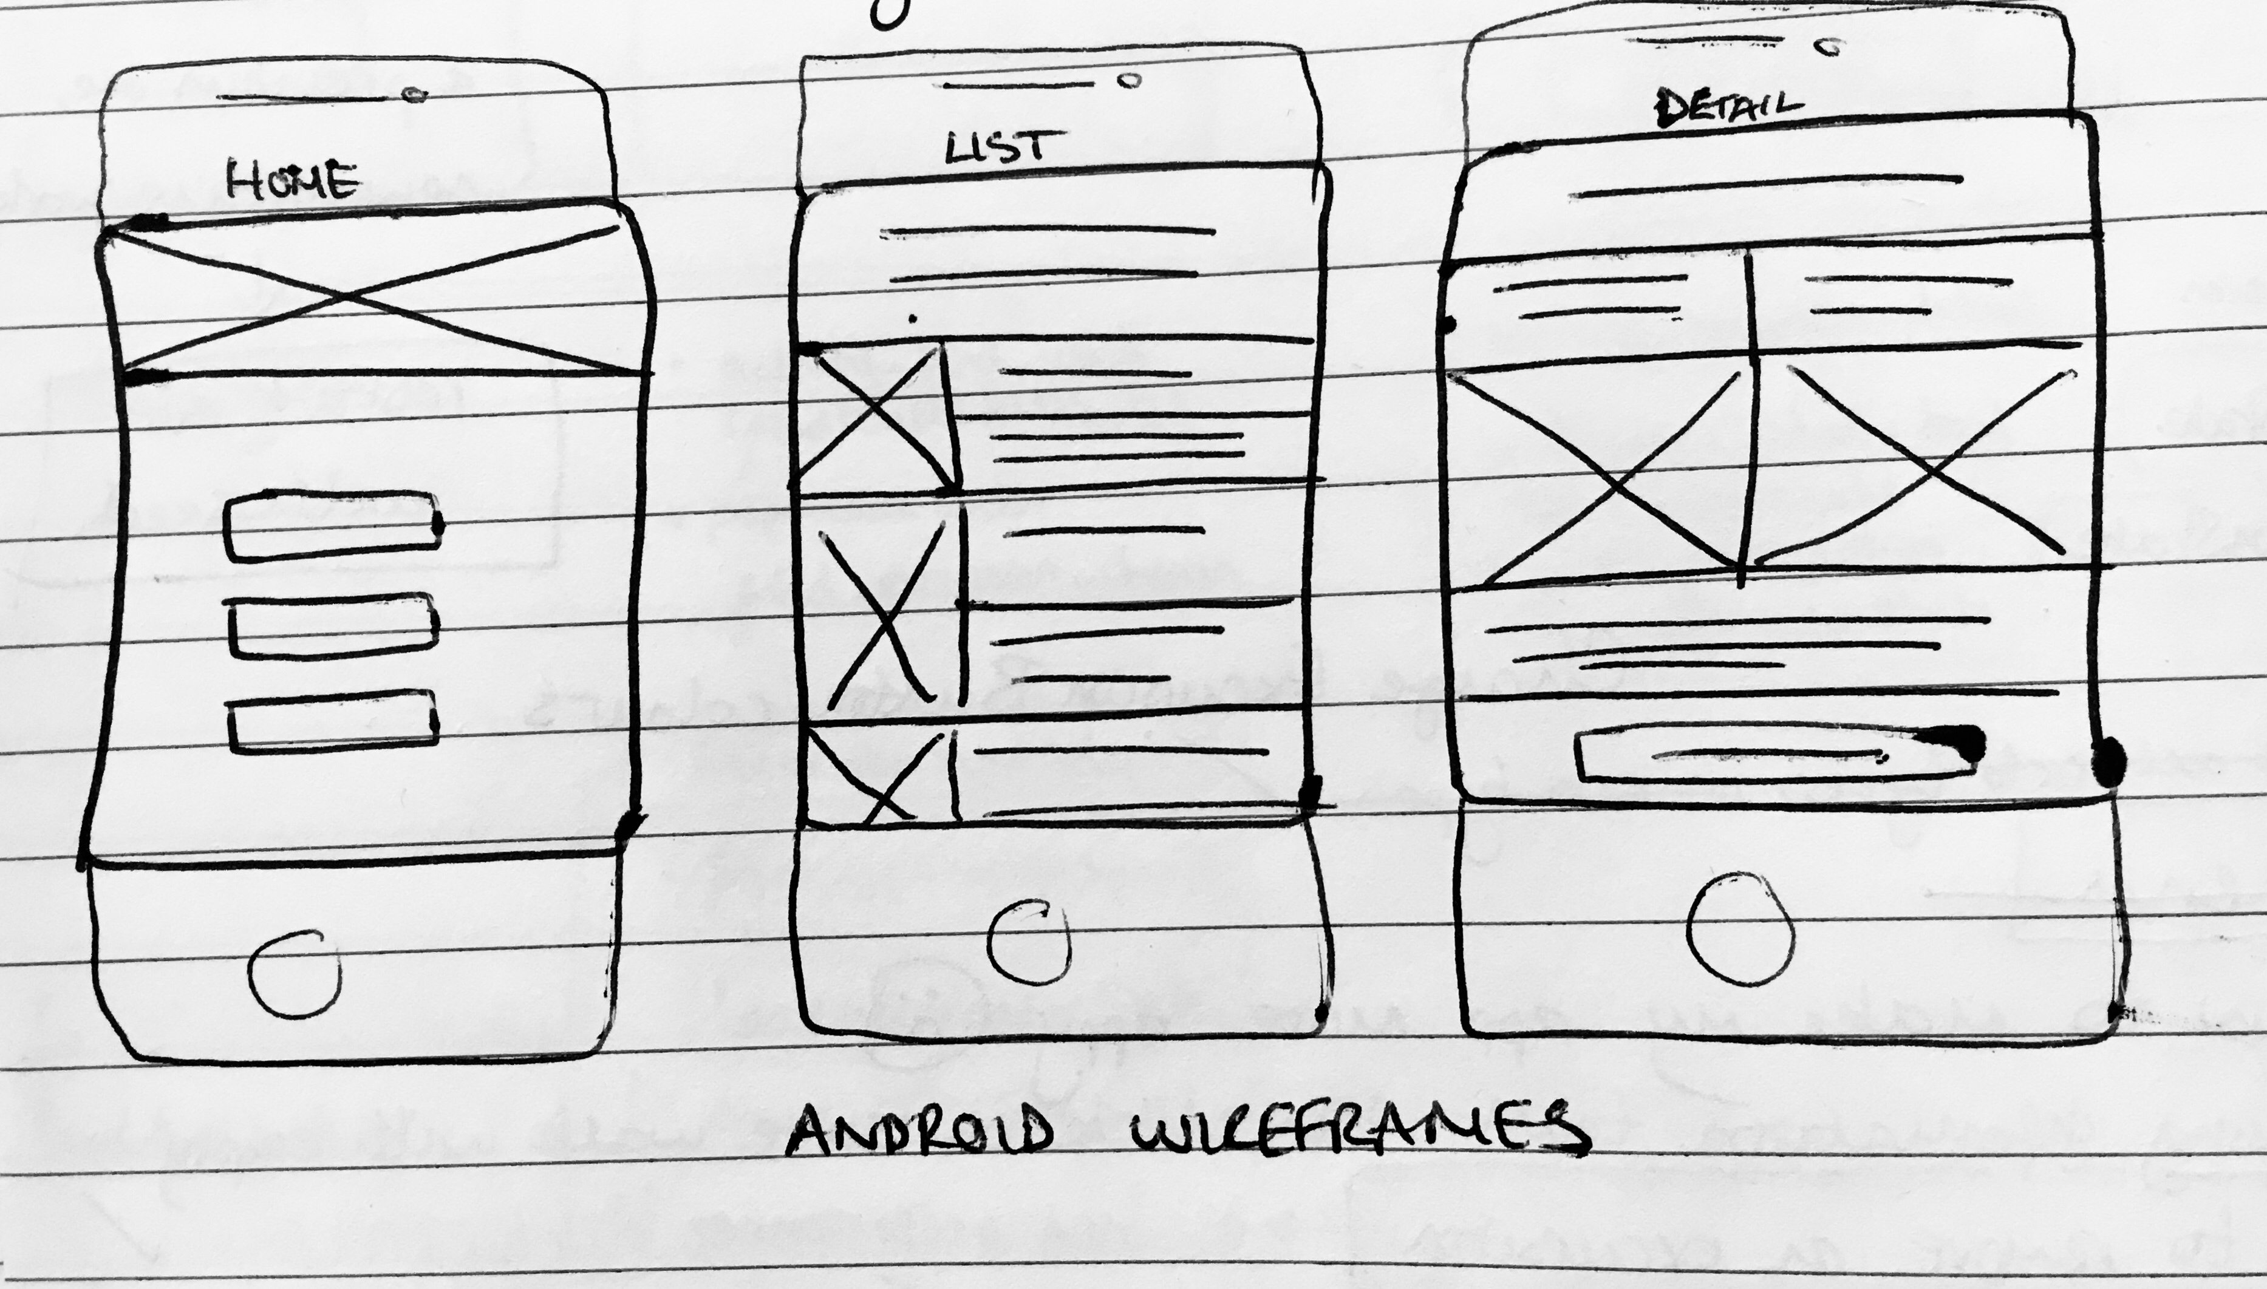

**P. 7 System interactions diagrams**

Two collaboration diagrams provided in sketch below

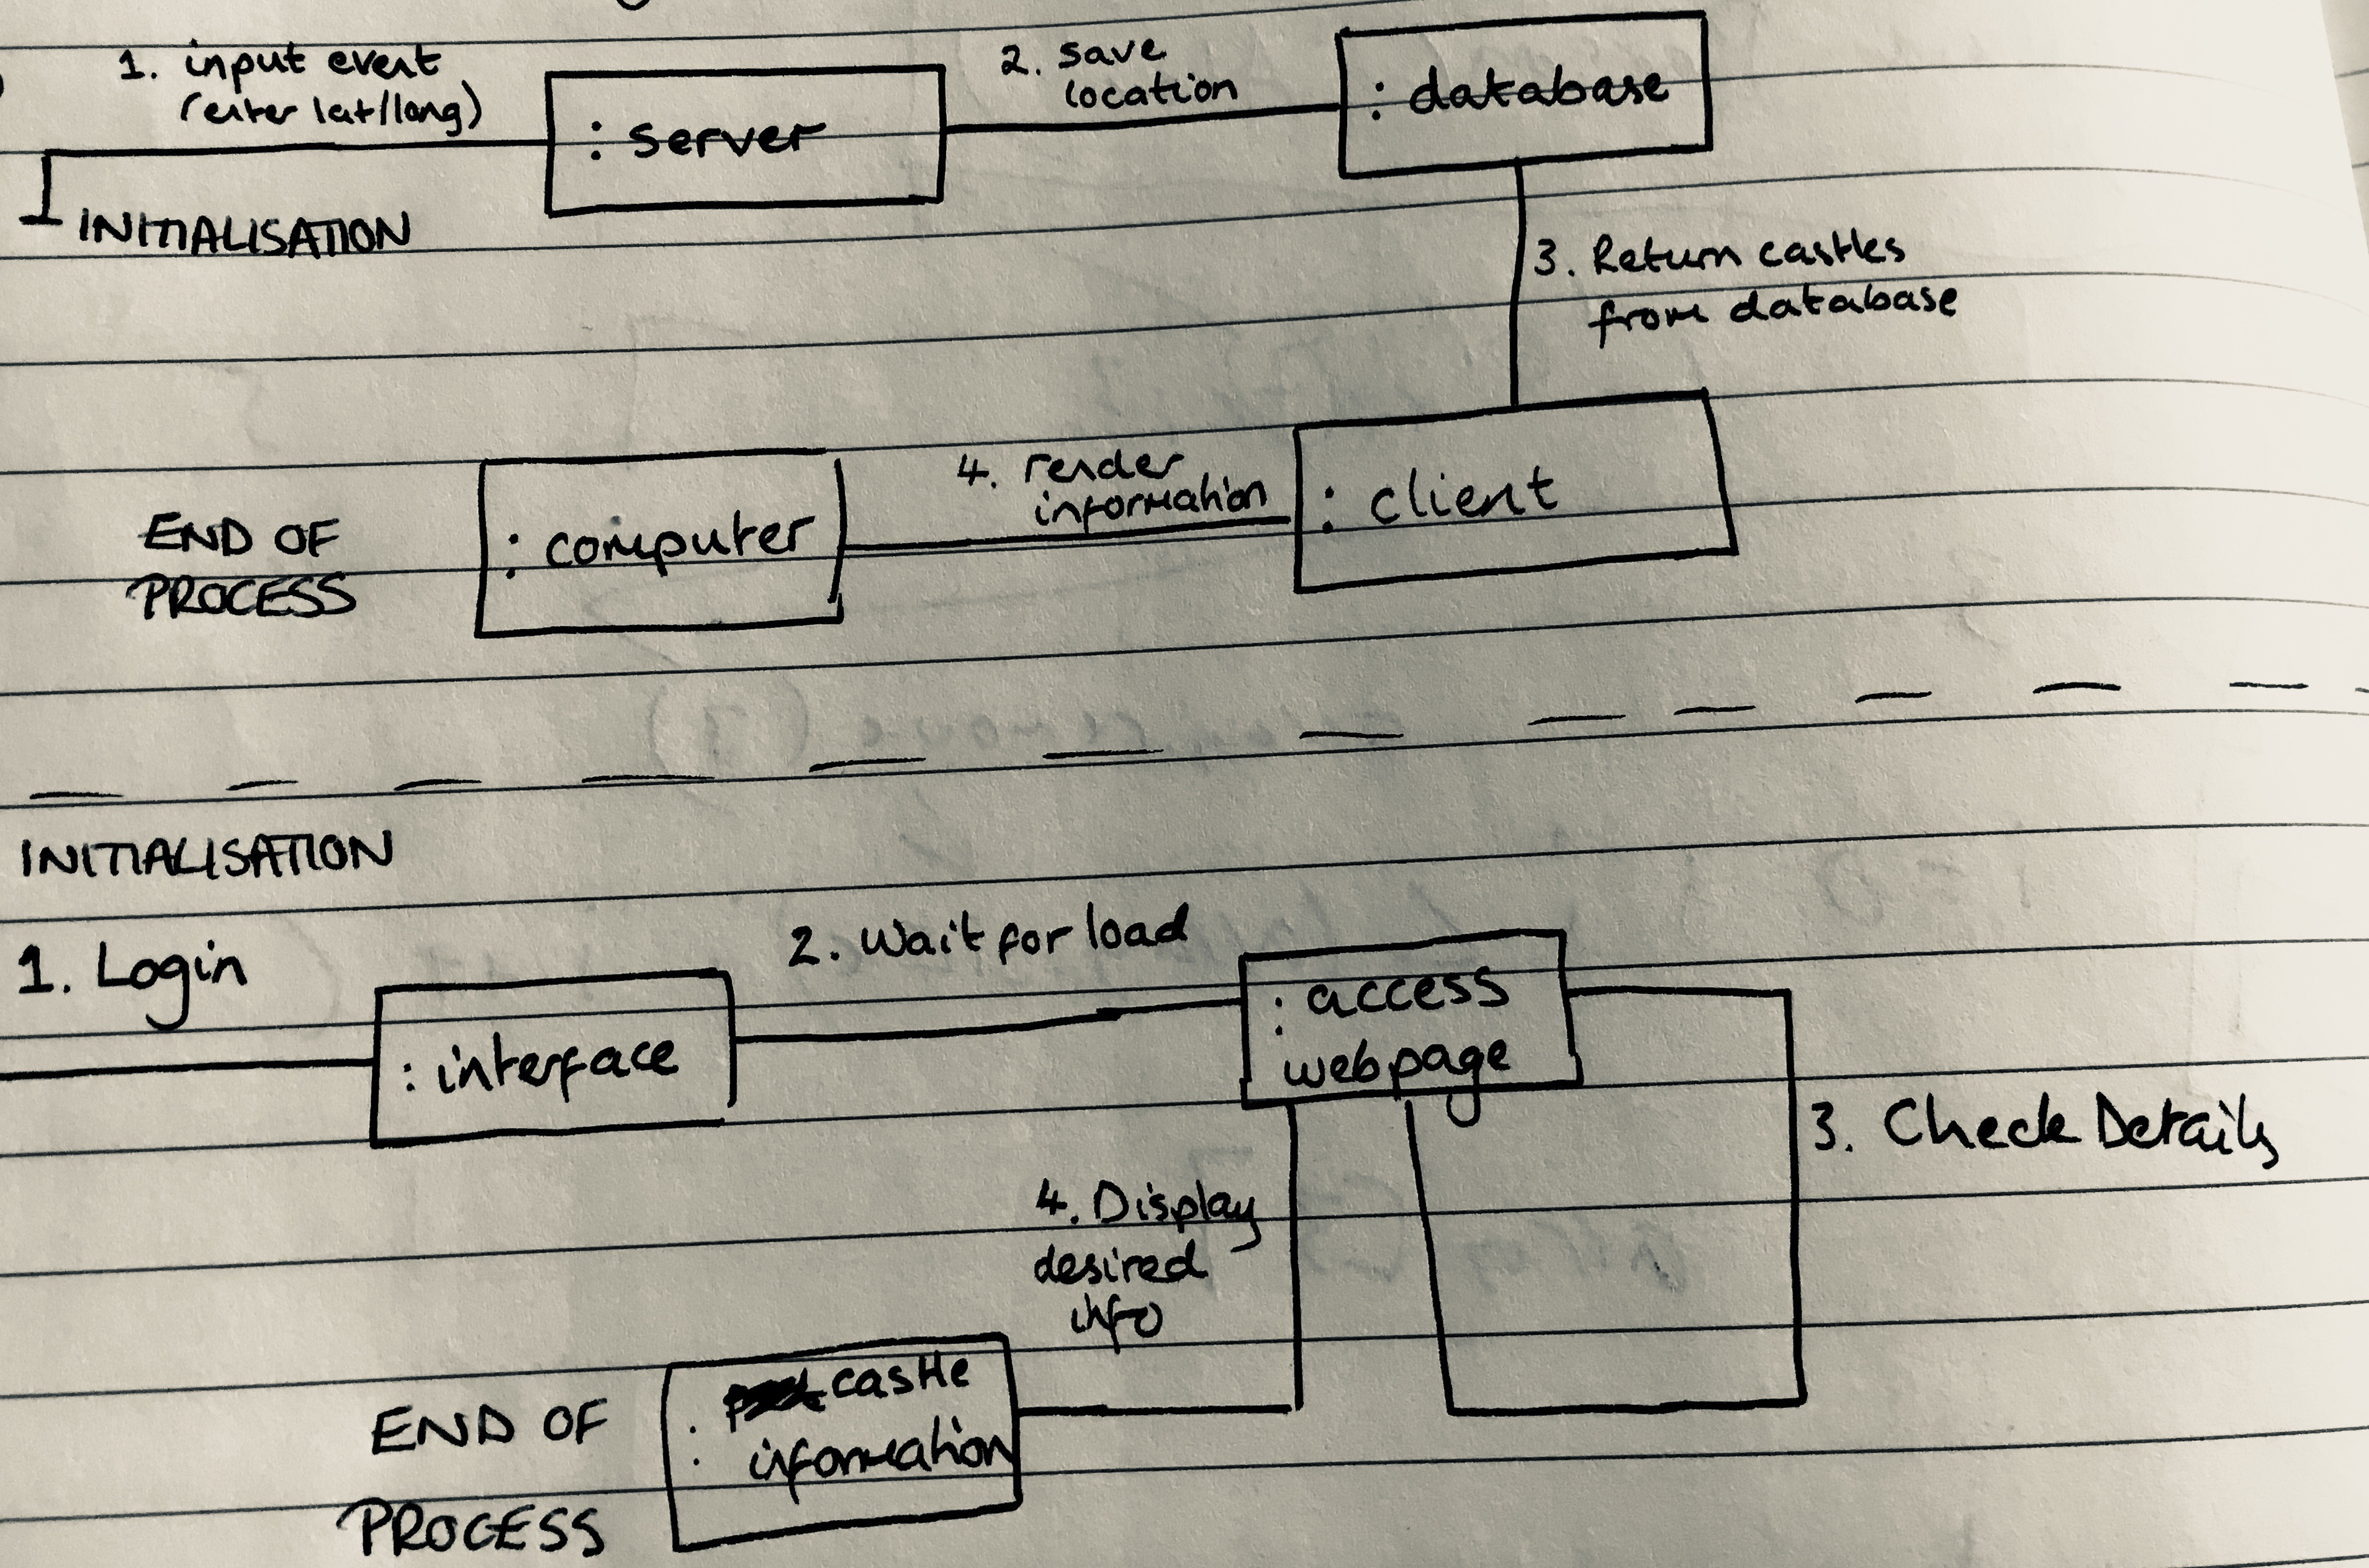



**P. 8 Two Object Diagrams**

Two object diagrams are provided below: one for the Castle project and the other for the Geodiversity Sites project.

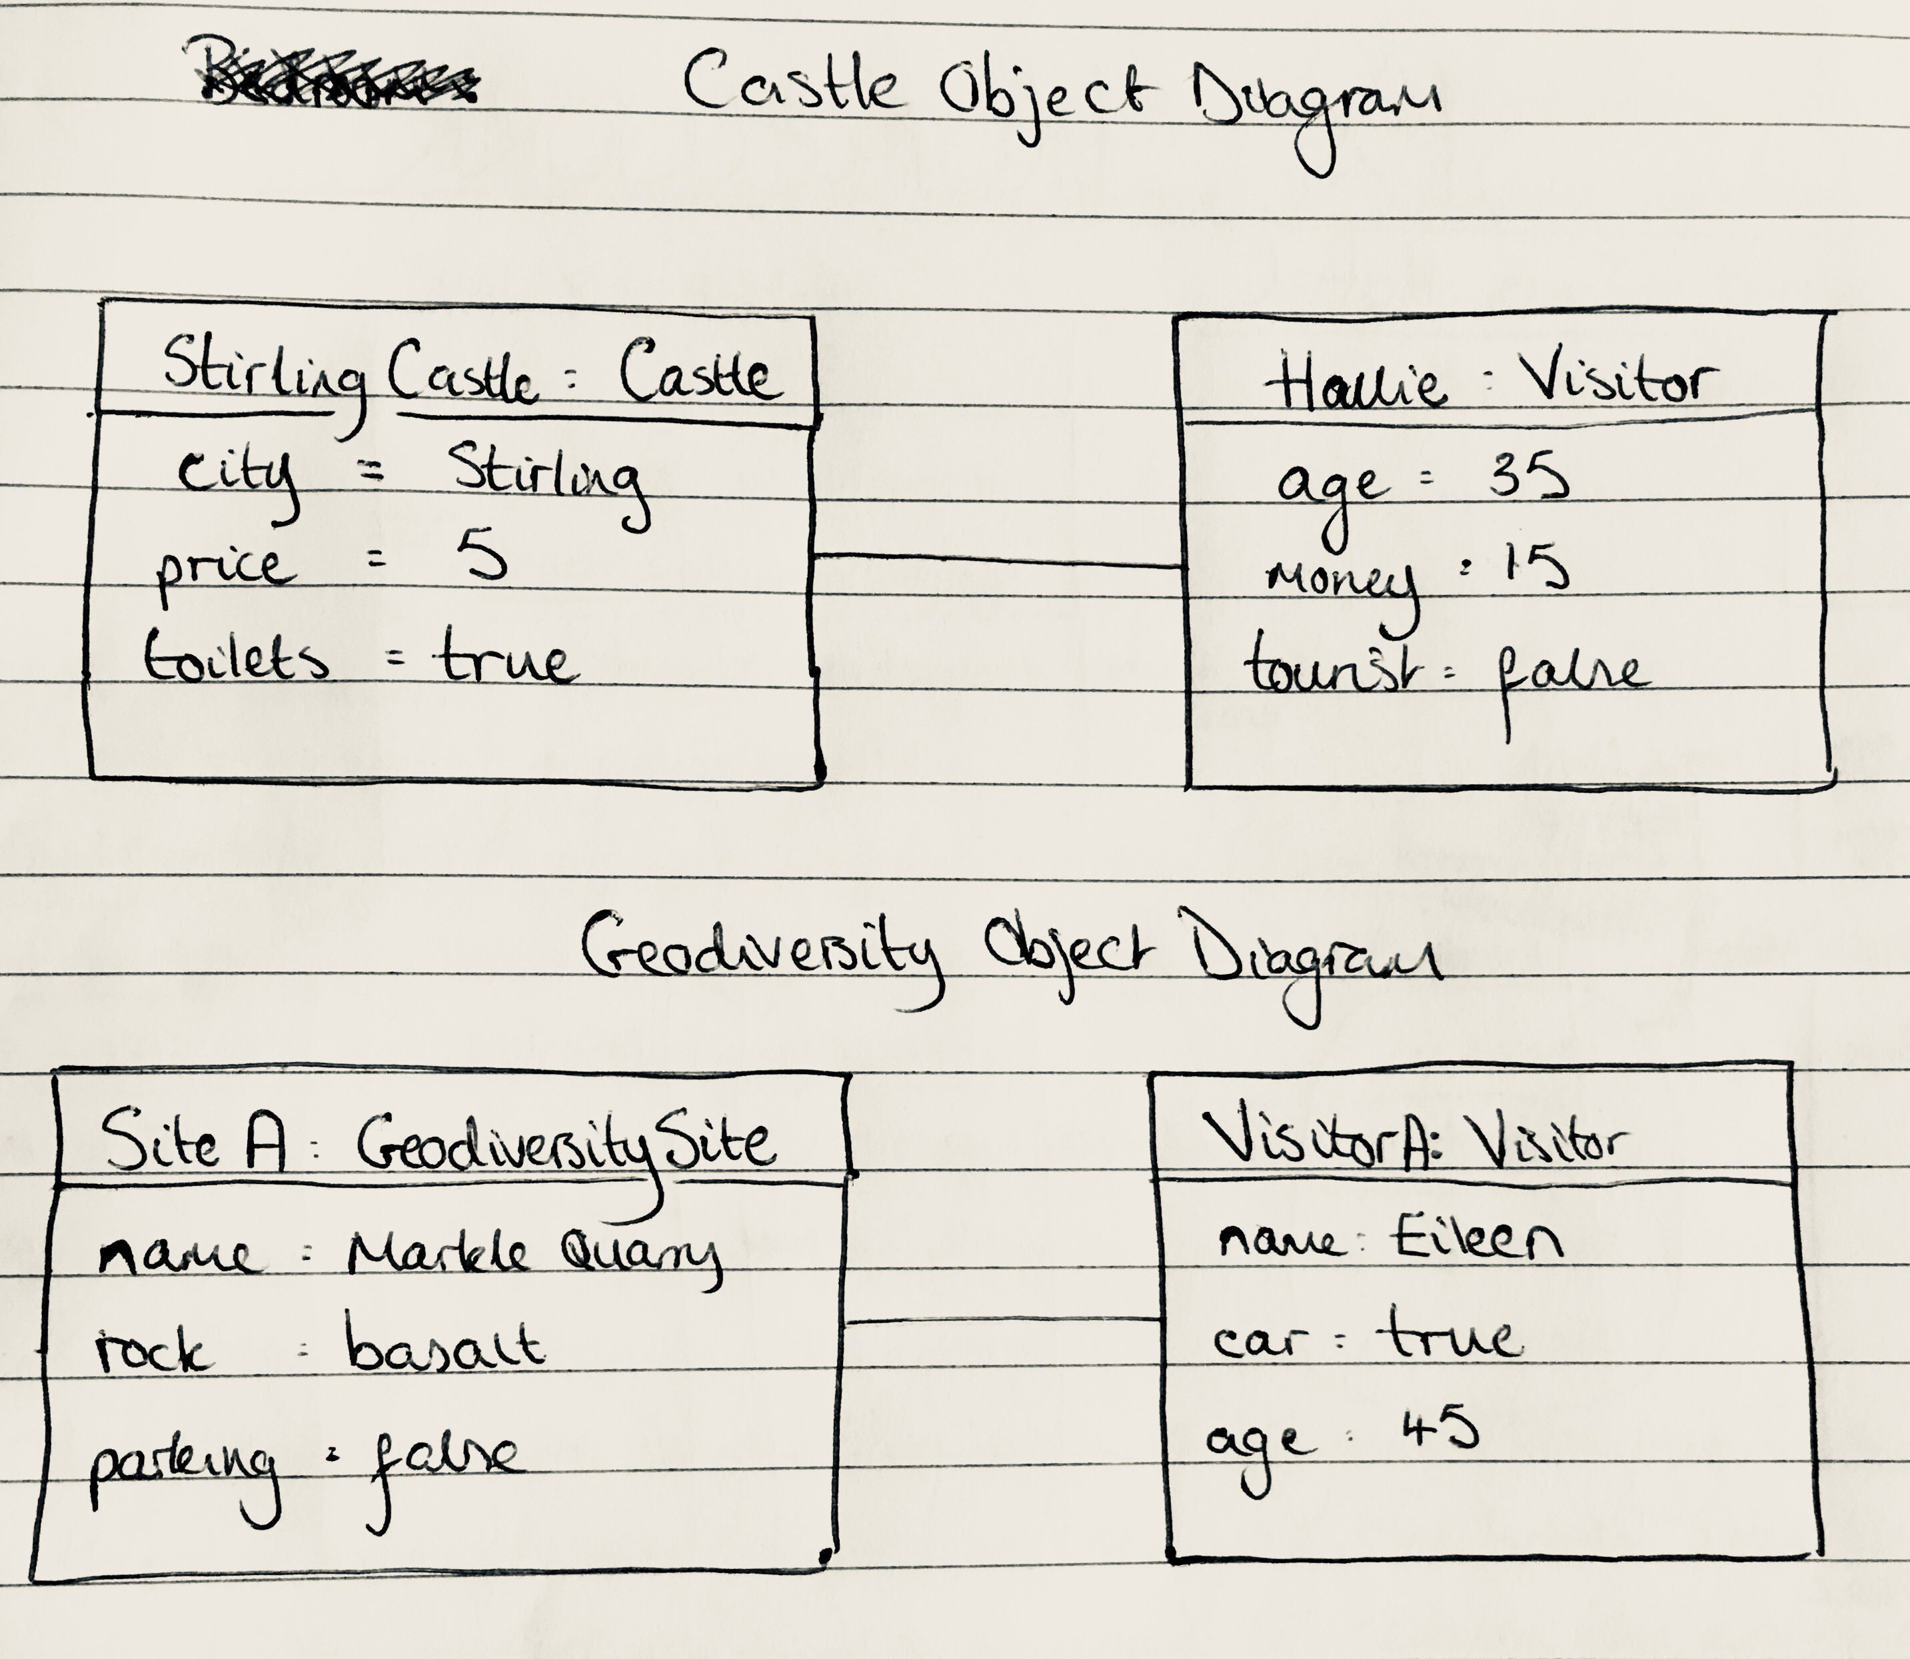

**P. 9 Choice of two algorithms (find the algorithms on a program you might have written, show the code you have used )**

**On this example please take a screenshot and write what it is doing and why you decided to use it.**

**Algorithm 1:**

The algorithm below returns the name of a geological period/era (items found in an array) which is found within the array list called geologyInfo. This is important to use to extract all information from an array to display data. The method ‘getNameOfPeriodInGeologyInfo’ sets up an empty string (periodName) and then uses a for loop to loop through the size of the array list called geologyInfo. Then, for every index in geologyInfo, call the method getEraTypeNames, take what that returns, and add it to the empty string periodName. See the next algorithm example for what getEraTypeNames does.

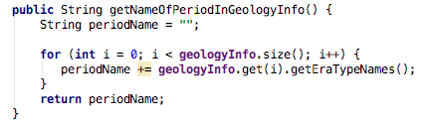

Figure 1: Algorithm 1 screenshot

**Algorithm 2:**

This algorithm is the method that was called in the above algorithm (Algorithm 1) on the array list of geologyInfo, and it returns a neatened version of a string containing the geology period. The method getEraTypeNames sets up a string containing some characters, then uses a for loop through a class method (getEraTypes), to return an array. The for loop then returns what is captured within that array using the era.getGeologyPeriod method (returns a string from an enum), and adds a comma and space at the end of it. Then, it makes a new string called eraNamesNeat, which removes the last 2 characters from the end of the string so that there are no errand commas for the final returned string. That neatened string is then returned.

**­­­­­­**

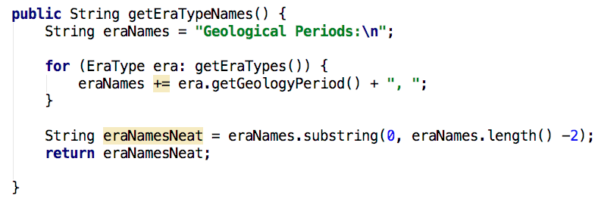

Figure 2: Algorithm 2 screenshot

**P. 10 Example of Pseudocode**

Pseudocode in Android/Java project

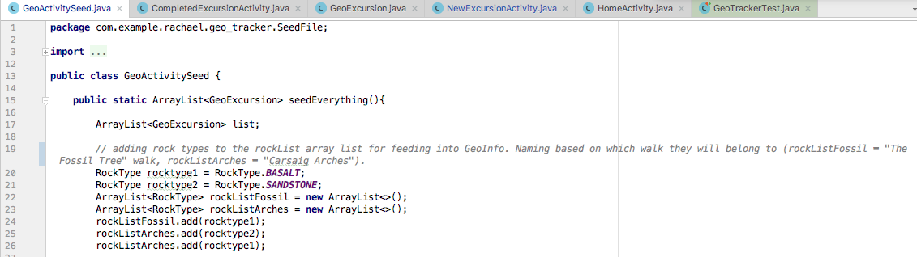**P. 11 Github link to one of your projects**

[**https://github.com/Rachael-E/cc_w5_cat_shelter**](https://github.com/Rachael-E/cc_w5_cat_shelter)

**P. 12 Screenshot of your planning and the different stages of development to show changes.**

Use of Trello for planning showing the different stages of development, reflected in the ‘to do list’ and ‘working on’ lists.

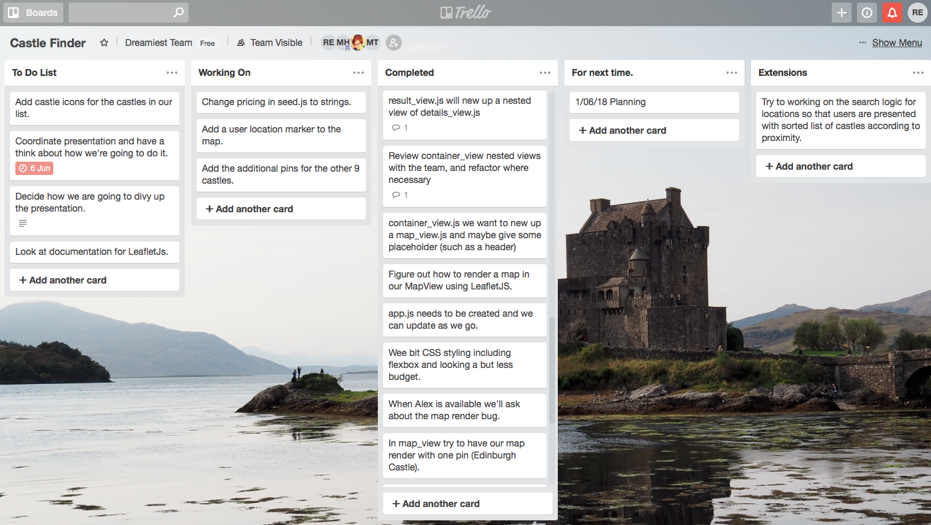

User Need document to demonstrate planning of the project for the Castle Finder. Reflects the changing needs of the user as the product design phase develops.

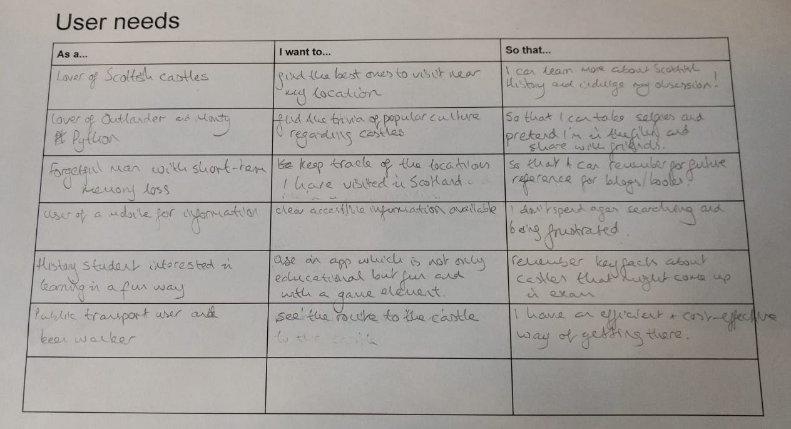

**P. 13, 14, 15 combined: User input/ Interaction with data persistence/ User output result**

User can go to home page of app, and click ‘add your own excursion’. This opens a new app page where information can be entered. This can then be saved, and when back on the homepage, can click on ‘Find an Excursion’, which will then display the summary of the added entry, and then the full details when clicked.

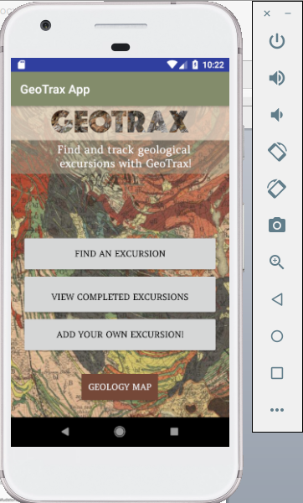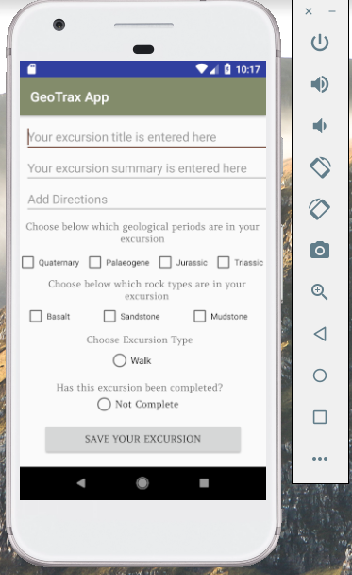

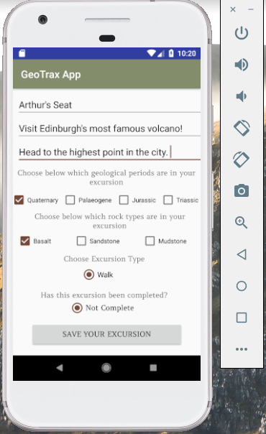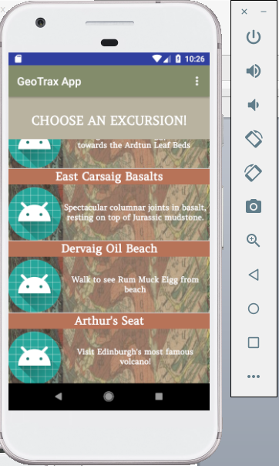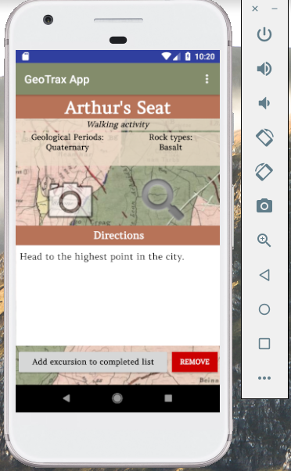

**P.18 Show an API being used within your program**

This example makes use of the REST Countries API, and also the ArcGIS JS API to run maps. The first screenshot shows the REST Countries being brought in, and the second the ArcGIS JS API brought in. The final screenshot shows the two APIs used in a web application.

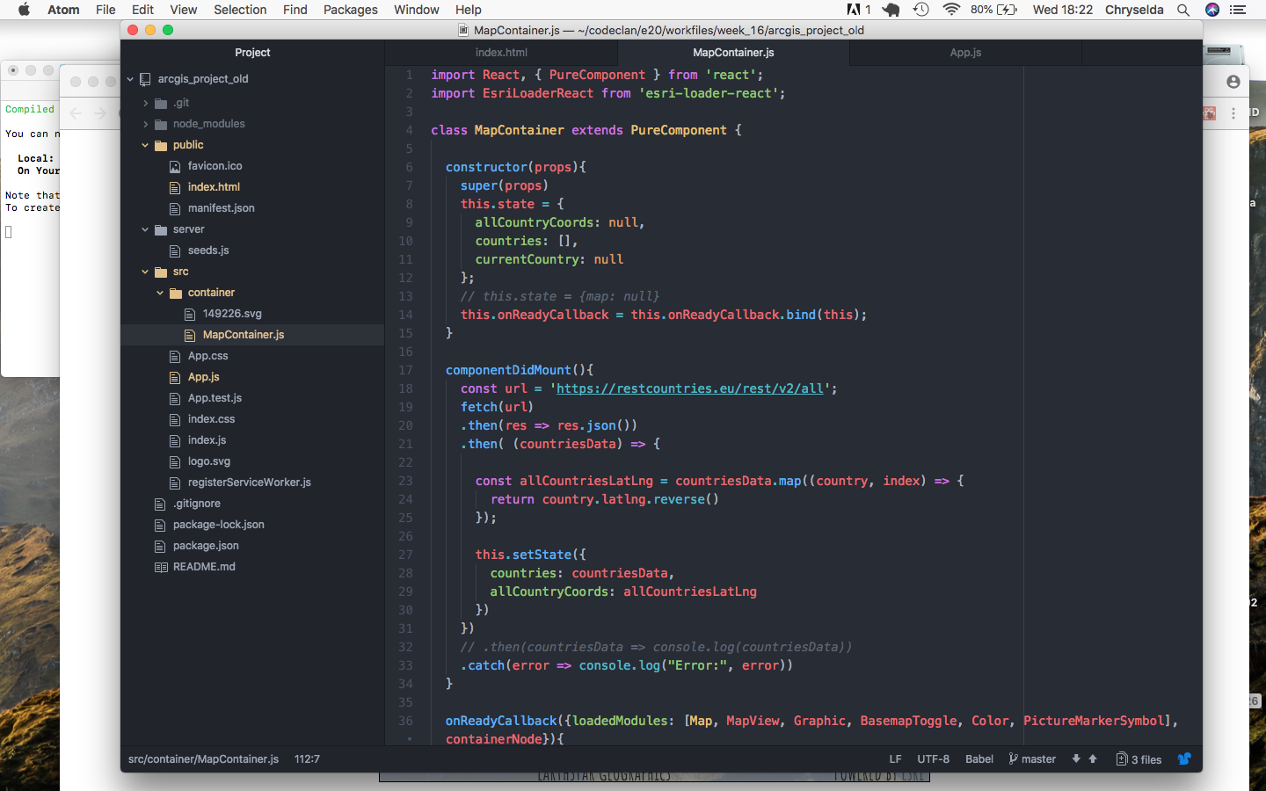

Figure 3: REST Countries API being required in program

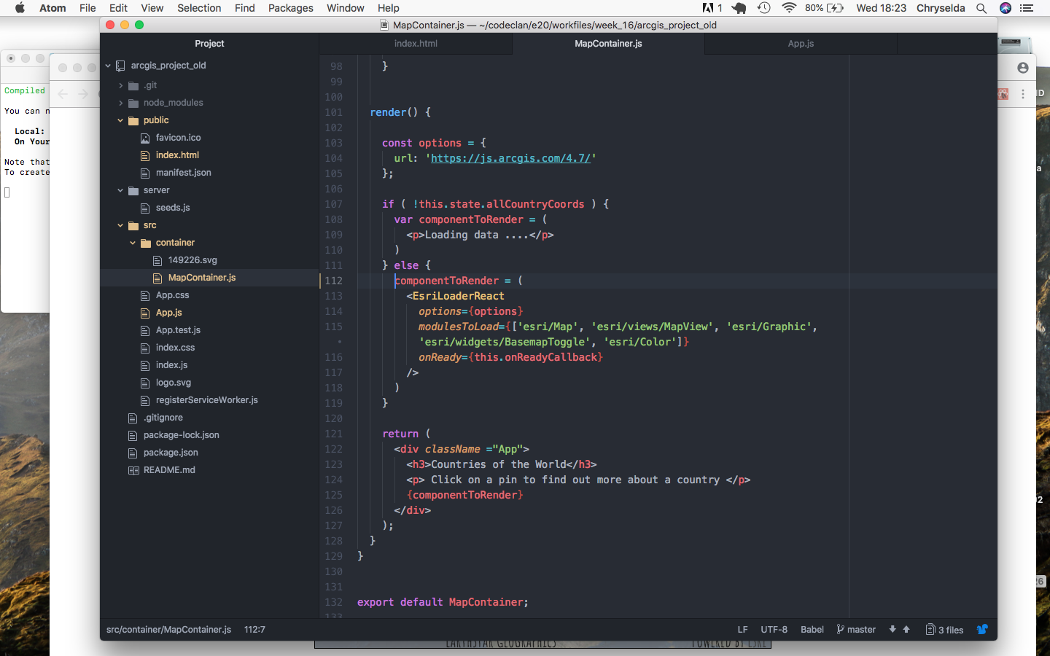

Figure 4: ArcGIS JS API being required in the program

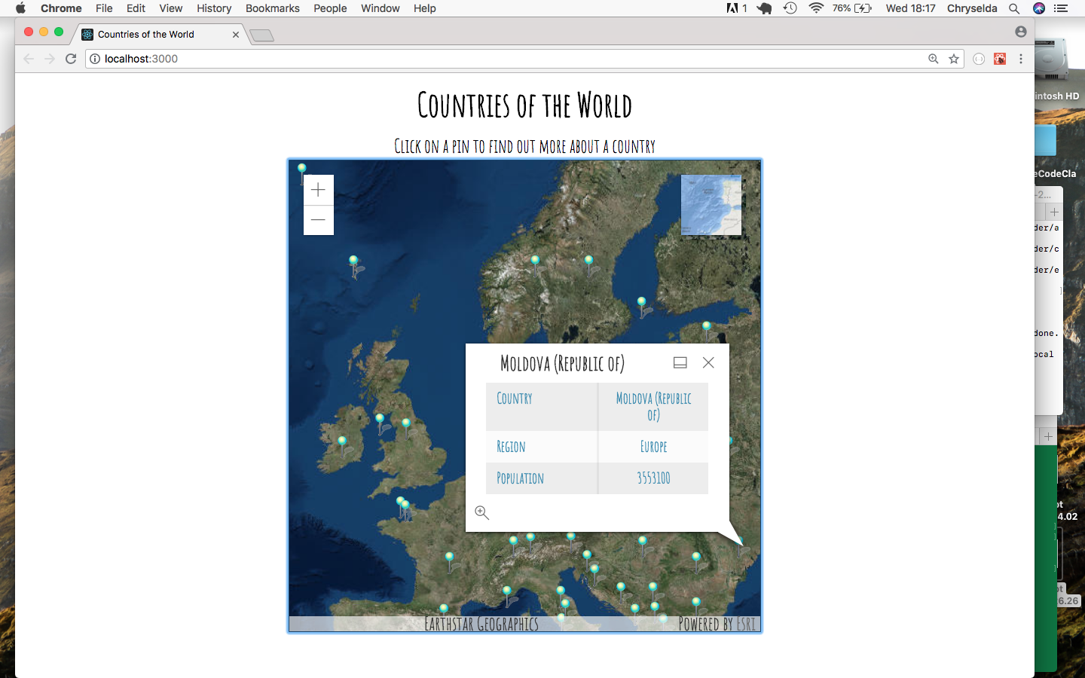

Figure 5: Final web app which uses the REST Countries API combined with the ArcGIS JS Map API to display information about a country.

**P. 17 Bug tracking report showing the errors diagnosed and corrected.**

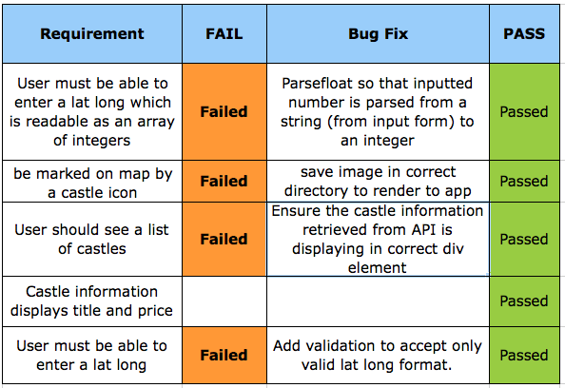**P. 18 Testing your program**

See examples of tests below: failing, and then passing following solution. Separate screenshots for passing and failing.

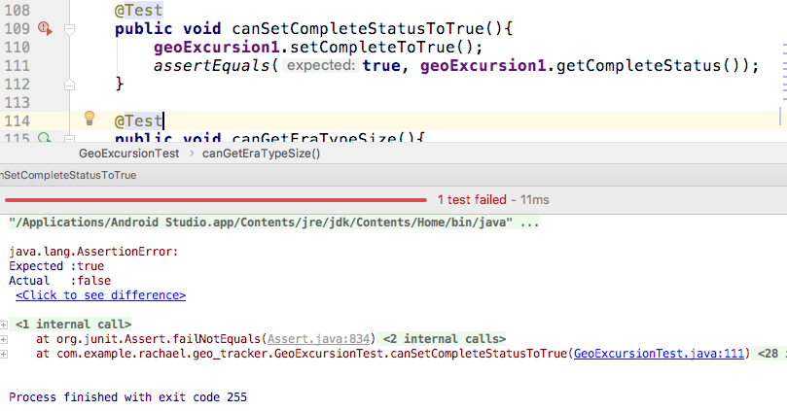

Figure 6: TEST 1: Test fails, because code was incorrectly written: it returned false instead of true.

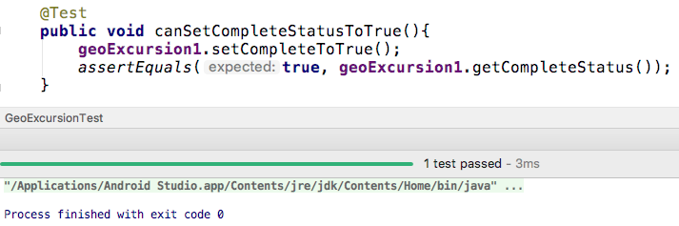

Figure 7: TEST 1: Test passing because erroneous code was corrected: it returns true now, as expected.

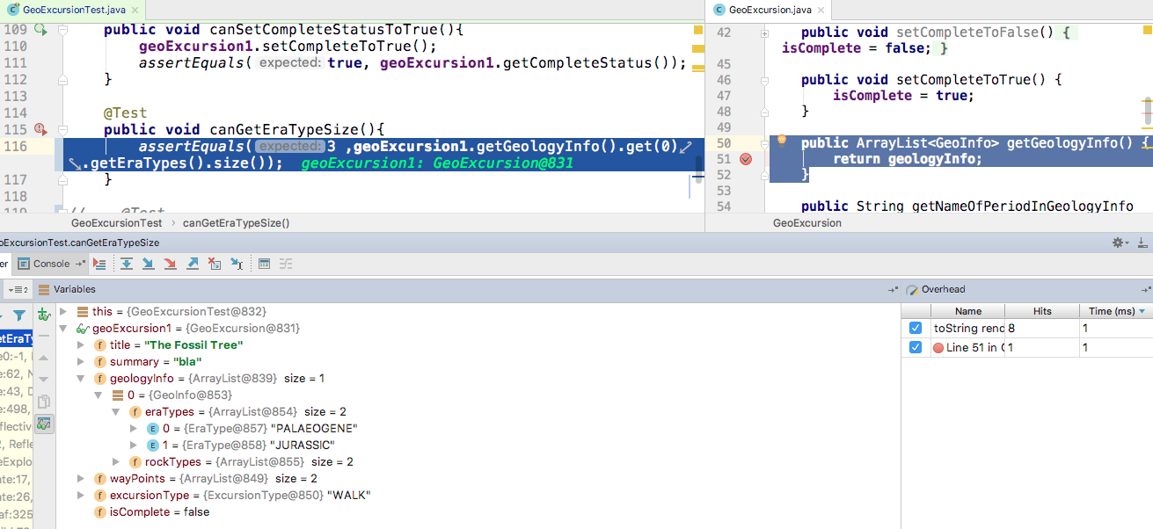

Figure 8: TEST 2: Showing debugging report when checking why a test is not passing

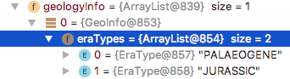

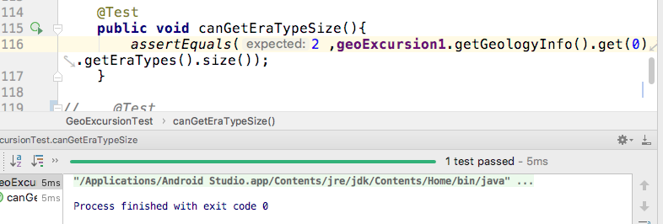

Figure 9: TEST 2: Following debugging, expected result is now corrected and the test passes.